**Technical information**

**EURANET+**

Euranet+ is a consortium of European national and international radio stations created in 2007 with support from the European Commission. The network’s objective is to provide a pan-European view of EU news.

Each member produces and broadcasts its own programmes, such as the weekly *500 Millions d’Européens (500 Million Europeans)* on BFM Business.

The network also has an editorial team in Brussels (Euranet+ News Agency), which produces interviews, reporting and programmes that are available to all members.

There are several European networks which share images, such as UER (Eurovision) for public TV channels and Enex for private channels, but Euranet+ is the only network in Europe which offers genuine editorial coordination.

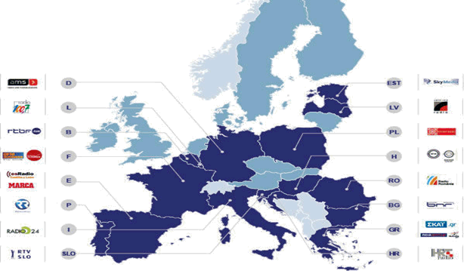

**KEY FIGURES**

* 18 public and private radio stations across the EU
* 22 million daily listeners in total
* 1,600 hours of programming on European issues
* 15 working languages

**EDITORIAL BOARD MEETING**

Annual meeting of editors-in-chief and European programme managers from each member of the network to coordinate content (around 20 people).

A key item on the agenda for this meeting on 3 and 4 October is the development of shared “data driven journalism” content, i.e. journalistic content based on compiling data from different countries.

The meeting is led in English by Dominique d’Olne, the network’s coordinating editor and Head of Radio News at RTBF (Belgium).

An expert from Monaco start-up 10to11, which specialises in big data, is expected to be invited to contribute to the discussion and to help the network develop specific tools.

**WHY MONACO IS HOSTING THIS MEETING**

* To raise awareness among managing editors from 16 European countries of the negotiations currently under way between the Principality and the European Union with a view to establishing an association agreement, and to highlight, on the ground, the features which make Monaco unique.

To encourage an interest in reporting among the political journalists in attendance and thereby gain press coverage, Yann-Antony Noghès will send an informal briefing on the negotiations between Monaco and the EU and what is at stake to the various participants (based on a summary of the documentary for Arte).

Euranet Plus editorial board meeting: Monday 3 and Tuesday 4 October at the Novotel hotel

For more information, see: <https://www.rtbf.be/info/dossier/euranetplus> (available in French only)